Access to Continuous Care for HIV Positive Adolescents in Ukraine

This Report has been prepared by
East Europe and Central Asia Union of People Living with HIV within the UNICEF supported project Strengthening of Service Providing Community Networks and Leadership Skills of Adolescents Affected by HIV/AIDS

2015
Author:
Olga Panfilova, Senior Project Manager, Coordinator of Programmes for Adolescents implemented by East Europe and Central Asia Union of People Living with HIV;

We would like to acknowledge the input made by adolescent activists of East Europe and Central Asia Union of People Living with HIV: Yana, 17 years; Danyil, 17 years; Yana, 16 years and Alexander, 17 years old.

This Report exclusively represents the opinions of the ICO East Europe and Central Asia Union of PLH, which may not coincide with the official position of UNICEF and UNDP.

Content

Оглавление
Executive Summary 4
Introduction 5
1. Analysis of the Situation with the Provision of Services to HIV Positive Adolescents in the Regions of Ukraine 6
1.1. Cases of ARV Treatment Interruption among Adolescents 6
1.2. Availability of Regional Mechanisms to Resolve Crisis Situations Related to ARV Treatment Interruption by Adolescents 8
1.3. Reasons Why Adolescents Refuse from / Stop Taking ARV Therapy 9
1.4. Availability of Experience of Work with HIV Positive Adolescents in the Regions 10
2. ECUO PLH Initiatives to Develop Leadership Skills in HIV Positive Adolescents and to Change Approaches to Service Provision 14
Conclusions and Recommendations 16
List of Abbreviations 18

Executive Summary
This Report provides an situation analysis of services provided to HIV positive adolescents in Ukraine to meet their health, emotional and psychological needs.
Primarily, this Report reviews and describes in detail the results of analysis of the following issues:
- cases of ARV treatment interruption among adolescents;
- availability of regional mechanisms to resolve crisis situations related to the ARV treatment interruption by the adolescents;
- reasons to refuse or discontinue taking ARV drugs among adolescents;
- availability of experience of work with HIV positive adolescents in the regions of the country (disclosure of HIV status, conducting a regular group and individual work, engagement of adolescents as leaders and peer counselors).
Also, the Report contains a brief description of online platform initiative of ECUO as a timely response activity for HIV positive adolescents in the conditions of limited resources – i.e., a Youth Project Teenenergizer! (teenergizer.org), the closed group for HIV positive adolescents in VKontakte social media, consultations by psychologists and peer counseling.
In the end, the Report provides recommendations on how to find alternative funding sources and methods to develop adherence of HIV positive adolescents to ARV therapy and prepare them to the transfer to adult clinics in the conditions of a reducing Global Fund support to programmes for HIV positive children and adolescents and with the limited resources in general.
Key Recommendations:

- To preserve the existing experience in the provision of services to HIV positive children and adolescents there is a need to create a network of organizations that work with adolescents, with the ECUO PLH support.
- Taking into account a difficult political situation in Ukraine, the military conflict in the East of the country and economic crisis there is a need to change approaches to the provision of services to adolescents living with HIV.
- To ensure open communication with the adolescents there is a need to change social and professional norms among health and social workers.
- To develop adherence to ARV therapy and to prevent treatment fatigue among HIV positive adolescents there is a need to involve adolescent leaders as peer counselors.

Introduction
An estimated 3,700 HIV positive adolescents are living in Ukraine today. Unfortunately, around 100 adolescents aged 10 to 19 years died of AIDS in 2013. Efficiency of treatment of adolescents living with HIV is much lower than of other population groups. The risk of treatment failure and development of HIV drug resistance is higher among young people than among other age groups, because adolescents are facing additional difficulties to adhere to treatment regimen.
Starting from 2004 Ukraine, supported by the programmes of the Global Fund to Fight AIDS, Tuberculosis and Malaria (the Global Fund), has been providing social and psychological support services to children and adolescents affected by HIV/AIDS. During 10 years of the GF programmes’ implementation in Ukraine, child centres on the basis of NGO were established in practically all regions and specialists were trained. Besides, in 2007 the state budget allocated funds to open 7 centres for HIV infected children and young people.
Since 2015 the Global Fund grant has been provided to Ukraine on the basis of a new funding model. The programme for 2015-2017 does not envisage provision of social and psychological support services to HIV positive children and adolescents in Ukraine.
Exclusion of ‘Medical Social and Psychological Support to HIV Positive Children’ as an activity area from the Global Fund programme has a negative impact on the health status of children and on the ARV treatment outcomes. Most of such children and adolescents are living in families in difficult living conditions. As a rule, parents or guardians of these children do not have an opportunity to ensure appropriate development and control of ARV treatment adherence among adolescents. In their turn, adolescents, who feel fatigue of twice-daily administration of medicines, begin to interrupt ARV therapy because the still cannot understand the threat of such actions to their own health. It leads to the deterioration of health in adolescents and to the development of HIV drug resistance.
It should be noted that in 2012-2014 within the Global Fund programme around 7,000 HIV positive children and adolescents affected by HIV epidemic were annually receiving medical, social and psychological support services. Annual funding amount was approximately UAH 4.5 million.
In the current situation some HIV servicing organizations try at least partially preserve their services for children and adolescents living with HIV at the expense of the funds provided by the city/regional social programmes (in Cherkassy, Poltava and other cities). Unfortunately, provision of vitally important services to HIV positive children and adolescents has become impossible in most regions of Ukraine since 2015.

Analysis of the Situation with the Provision of Services to HIV Positive Adolescents in the Regions of Ukraine
In 2013-2015 the representatives of East Europe and Central Asia Union of People Living with HIV (ECUO) made 19 technical support visits to the Ukrainian regions including Kiev within the project Strengthening of Service Providing Community Networks and Leadership Skills of Adolescents Affected by HIV/AIDS supported by UNICEF. Visits were focused on the analysis of situation with the provision of services to HIV positive adolescents to meet their health, emotional and psychological needs and to provide technical assistance. A special focus during these visits was put on the assessment of stakeholders and on the implementation of advocacy activities in order to inform local governments about the strategy targeted on the inclusion of services for adolescents living with HIV/AIDS in the systems of the governmental medical and social care.
Visits to the regions were made by a senior manager of ECUO with the involvement of 4 adolescent leaders who met with their peers and conducted support groups for them in the regions.
These visits helped to evaluate the availability and quality of services for adolescents living with HIV/AIDS. As these visits were made to the majority of Ukrainian regions, the analysis results can be perceived as representative for entire Ukraine.
The following issues were analyzed:
- cases of ARV treatment interruption among adolescents;
- availability of regional mechanisms to resolve crisis situations related to the ARV treatment interruption by the adolescents;
- reasons to refuse or discontinue taking ARV drugs among adolescents;
- availability of experience of work with HIV positive adolescents in the regions of the country (disclosure of HIV status, conducting a regular group and individual work, engagement of adolescents as leaders and peer counselors).
Detailed information on each of the above listed issues is provided below.

Cases of ARV Treatment Interruption among Adolescents
As was already mentioned, since 2015 all programmes to support children aged 0-18 years living with HIV were left without the Global Fund funding. Further activities for children and adolescents without changing the approaches to service provision is practically impossible. NGO employees who provided support and care services to children living with HIV were either fired or transferred to other projects, while the sustainability of programs for adolescents was not ensured by the government.
During the regional visits ECUO representatives had meetings with health and social workers of the oblast/city AIDS Prevention Centres. In 14 of 19 regions (74%) the paediatricians indicated that they often saw cases of ARV treatment interruption among adolescents (Chernihiv, Ivano-Frankivsk, Poltava, Odessa, Donetsk and other oblasts).
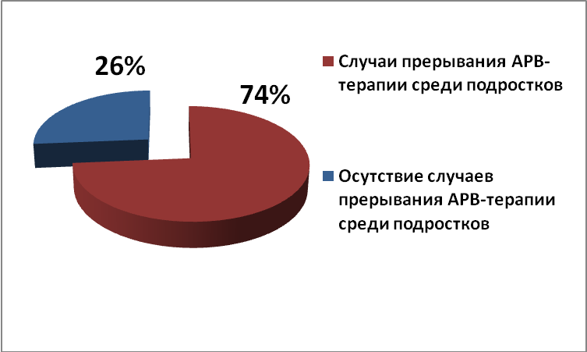
Fig. 1. Cases of ARV treatment interruption among adolescents in the regions
□ Cases of ARV treatment interruption among adolescents
□ Lack of cases of ARV treatment interruption among adolescents

Thus, for instance, in Ivano-Frankivsk it was found out from the conversation with a paediatrician that in spite of the rather small number of adolescents enrolled in care in the Oblast AIDS Centre (21 children are taking ARV drugs including 4 adolescents, and 6 more children will grow up in the next 3 years), it is very difficult to work with them. One adolescent aged 16 years has not been taking ARV therapy for 3 years. The paediatrician could not persuade him to renew treatment although his clinical test results significantly worsened.
According to the paediatrician in Poltava, seven of eleven adolescents living with HIV have interrupted ARV treatment. The doctor said that it was very hard to make them change their decision.
Another challenge mentioned by the paediatricians was the lack of system to prepare adolescents to the transfer to an adult clinic, which results in the refusal from taking therapy at the age of 18 years. In Odessa and Poltava young people were not taking ARV drugs for half a year when they were taken off the paediatric registers.
Also very often parents or guardians of children refuse to disclose HIV positive status to their children despite the fact that children have already reached the age of 15 years. In its turn it leads to the difficulties to develop ARV treatment adherence in adolescents.
So, paediatricians do not have an opportunity to influence the adolescent behaviour change and that is why the treatment interruption issues remain unresolved. Unfortunately, the doctor’s counseling time is limited and the paediatricians cannot deal with the arguments of adolescents who refuse to take ARV therapy: “I feel well without it”, or “I will die anyway”.
In order to find the solutions for these problems these cases were also discussed with chief physicians of the AIDS Centres. It should be noted that some chief physicians vehemently refused to undertake their own and their employees’ responsibility for the development of ARV treatment adherence in adolescents and for the retention of these patients in treatment programs, indicating that it was the responsibility of NGOs. Other chief physicians agreed that the work of AIDS Prevention Centres was very important, but they did not have a psychologist or a social worker in their staff lists, who could have developed treatment adherence in adolescents. In other cases chief physicians pointed out that their staff social workers or psychologists lacked skills and experience to work with children and adolescents because they mostly work with adults.
Also, the team had meetings with the employees of youth friendly clinics. During this meetings in most of the regions it was found out that the youth friendly clinics implement prevention activities among adolescents (senior schoolchildren, students of colleges, technical colleges, etc.). As a rule, testing for HIV is offered to adolescents since the age of 18 years. Any other special services for HIV positive adolescents (such as counseling by a psychologist, support groups, etc.) are not provided.
So, today health care facilities are primarily focused on the provision of medical services. Most of health workers do not have necessary skills and experience to provide comprehensive services to adolescents aimed at early detection of HIV positive adolescents, development of ARV treatment adherence and their retention in treatment programmes.

1.2. Availability of Regional Mechanisms to Resolve Crisis Situations Related to ARV Treatment Interruption by Adolescents
We found out that cases of ARV treatment interruption or refusal from treatment among adolescents were common in practically all regions. Often health workers find it out when clinical test results of adolescents and their health condition worsen. At the same time, both doctors and psychologists lack an understanding of an opportunity for free communication with adolescents on their issues of their health and ARV treatment adherence. Due to this approach the health specialists have to deal with the problems that arise, and not to prevent them.
In this situation the mechanisms to resolve crisis situation in order to restore the health of adolescents and to develop their adherence to ARV therapy, or to retain them in treatment become especially important.
Specialists of Vinnitsia Oblast AIDS Centre who observe ARV treatment interruption by adolescents are practicing routine rehabilitation of patients. This mechanism helps, first of all, to quickly and efficiently restore the health of adolescents and secondly, doctors, psychologists and social workers, who have regular daily contacts with patients during 2-3 weeks, have an opportunity to convince adolescents about the importance of ARV therapy, to develop their adherence to treatment and, subsequently, to retain them in treatment programmes.
On the national level, activities of the Centre “Clinic for Treatment of Children Living with HIV/AIDS” (OHMATDYT) also contribute to the solution of the especially complex cases of adolescent refusal from ARV therapy, which lead to the deterioration of their health. Unfortunately, not all regions refer adolescents who refused from ARV therapy, to rehabilitation at this health care facility even in very complicated situations.
Cherkassy Oblast AIDS Centre, however, works in close collaboration with Cherkassy Oblast Branch of All-Ukrainian Network of PLH, namely, with a psychologist and social worker of the Chidren’s Centre. It should be noted that a social worker and psychologist have established links with all adolescents and could overcome challenges related to ARV treatment interruption, taking into account a relatively small number of these adolescents. So, the issues of retention of HIV positive adolescents in Cherkassy oblast treatment programme are addressed by health workers in cooperation with an NGO.
Unfortunately, not all regions have similar mechanisms to resolve crisis situations. Only 7 of 19 regions (Poltava, Cherkassy, Chernihiv, Kiev, Vinnitsia and other oblasts) had at least some mechanisms to address crisis situations related to adolescent treatment interruption.
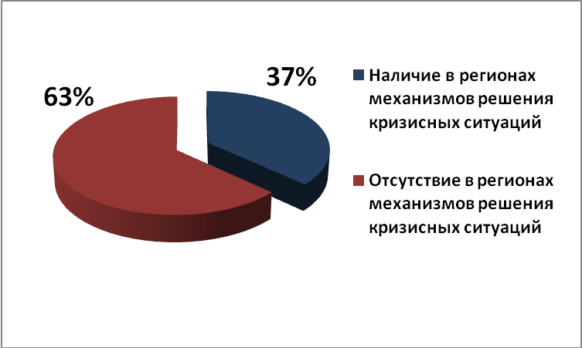
Fig. 2. Availability of mechanisms to address crisis situations related to adolescent ARV treatment interruption in the regions
□ Availability of mechanisms to address crisis situations
□ Absence of mechanisms to address crisis situations
Results of the study of this issue demonstrated that health care facilities can resolve crisis situations either independently, or with the involvement of social workers / psychologists from HIV servicing NGOs.

Reasons Why Adolescents Refuse from / Stop Taking ARV Therapy
Support groups were organized for HIV positive adolescents during the visits. Adolescent leaders from Kiev took an active part in the groups, providing peer counseling. In their communication with the peers they provided examples from their own life and invited participants to join the closed group in VKontakte “Here you will find a story that is like yours”, where HIV positive adolescents receive useful information about treatment, leadership development, etc.
Total 54 adolescents in 13 oblasts took part in the support groups during these visits. They could openly discuss main challenges faced by them in relation to their HIV positive status and it also helped to involve them in the discussion of most important issues using the online resources, such as the closed VKontakte group and the Youth Project Teenergizer! At the same time, social workers and psychologists could learn how to conduct support groups to openly discuss the topic of HIV status with teenagers.
While communicating with adolescents, health and social workers and psychologists we managed to identify key problems faced by HIV positive adolescents in Ukraine that result in ARV treatment interruption:
- Adolescents often have difficulties with the intake of medicines and poorly tolerate side effects.
- Absence of a close person with whom they could discuss their concerns and HIV issue in general leads to the social isolation of adolescents and to the increased stigma
- Many adolescents are orphans and are raised by their guardians. Besides, many families have low income and sometimes cannot meet even the basic needs of their children. It leads to the lack of communication in the families and to additional psychological crises in the adolescent age.
- Complicated relationships of adolescents with their family members, lack of contact with them (stepfather, guardians, older children in the family). It leads to the protest behavior among adolescents which can manifest itself in the form of ARV treatment interruption or refusal to take medicines.
- Closeness and inability of adolescents to discuss complex topics, e.g., thoughts about death, unwillingness to take pills, fear to disclose their status to a close friend, feeling of loneliness, shame, fear of the future, lack of knowledge about how to disclose one’s status to a potential lover, etc.
- Residence beyond the central oblast cities that limits their opportunities to receive social services. Adolescents often go to AIDS Prevention Centres once in three months to be tested and receive ARV drugs.
- Adolescents also experience stigma and discrimination in their environment. Most often it happens in small towns where rumours spread very quickly.
Adolescents who participated in the support group sessions were frank and told that they had experience of treatment interruption for about a month. In general they said that they were not taking medicines on a regular basis because they forgot about it, and at the same time they did not have any concerns or worries about it.
So, these group sessions have once again confirmed the fact that adolescents often stop taking ARV drugs or take them irregularly. This means that after the disclosure of their HIV status there is an urgent need to continue regular work with adolescents to develop their adherence to treatment and prevent ARV treatment fatigue.

Availability of Experience of Work with HIV Positive Adolescents in the Regions
It should be noted that in 2007 the government supported the idea of All-Ukrainian Network of People Living with HIV to organize the activities of centres for HIV infected children and youth as the governmental institutions. In 2007-2008 seven centres for HIV infected children and youth were opened at the state budget expense: 2 centres in Kiev and one center in each of the following regions: AR Crimea, Lugansk, Odessa, Kharkiv and Dnipropetrovsk oblasts. The key goal of these centres is to create conditions for social adaptation of HIV positive children and youth, top develop and implement activities aimed at social support and follow-up to these children and young people in order to integrate them in the society.
Also, Children’s Centres conducted activities to support HIV positive children and adolescents on the basis of NGO in practically all central oblasts cities within the Global Fund programmes.
In each region the team had meetings with the NGO employees working with children and adolescents affected by HIV/AIDS (regional offices of All-Ukrainian Network of PLH and other HIV servicing NGOs). The experience of NGOs to work with HIV positive adolescents and the services provided by them were evaluated.
It was found out during the meeting with Children’s Centre of Cherkassy Oblast Branch of All-Ukrainian Network of PLH that all HIV positive children in Cherkassy oblast (86 children aged 0-18 years) were clients of this Children’s Centre. Today services are being provided to 5 adolescents in Cherkassy oblast. The organization has experience of work with children and adolescents thanks to participation in the project Children+ in 2008-2013г. In general, this experience includes disclosure of HIV positive status to children, support groups for adolescents and their parents. The employees also conduct support groups for adolescents twice a month, though they said that adolescents do not always visit these groups on a regular basis. To address this situation the employees conducted a survey among adolescents to find out their preferences and needs. Also, Cherkassy Oblast Branch of the All-Ukrainian Network of PLH in cooperation with the US Peace Corps volunteers organized two summer camps for children and adolescents, who knew about their HIV positive status; each of these camps had 80 children and adolescents from the regions of Ukraine. Unfortunately, this activity is now suspended due to a difficult political situation in Ukraine.
Employees of the Club Svitanok NGO from Donetsk implement follow-up to HIV positive children. They manage 90 children including 33 adolescents. A social worker is in a constant contact with the adolescents, calling them twice a day to provide support in the ARV treatment adherence. Also, a psychologist facilitated support groups for adolescents twice a month. One of the weak points of work with HIV positive children and adolescents in Donetsk oblast is an insufficient coverage of children with these services, because there are 565 HIV positive children (aged 0-18 years) in the oblast; 440 children are taking ARV therapy. In the age group 11 to 18 years there are 159 HIV positive adolescents and in the nearest 3 years 189 more children will come of adolescent age. Moreover, due to armed conflict in Donetsk oblast and due to a large number of internally displaced people the provision of these services to adolescents became problematic since mid-2014.
It should also be noted that not all regions have the experience of work with HIV positive adolescents. Oftentimes, after the disclosure of HIV positive status to an adolescent there is no further work with them, because psychologists and social workers do not have necessary experience. Some NGO do not even have knowledge about how to disclose HIV status. Also, the specialists find it difficult to openly discuss HIV topic with adolescents in practice. Psychologist provides counseling to adolescents focusing on general issues and ignoring the topics of how to live with HIV. Due to this the adolescents do not have people with whom they could have safely discussed their HIV positive status.
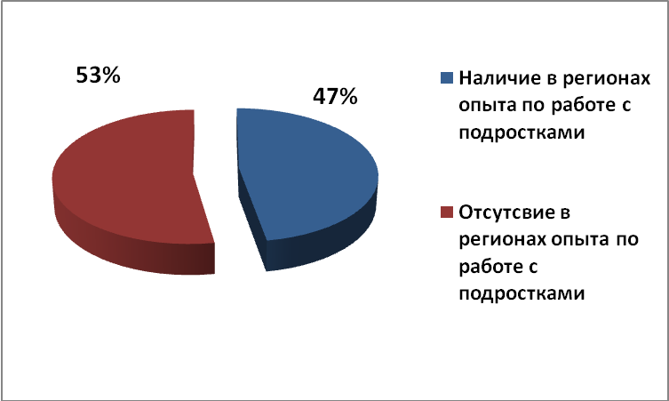
Fig 3. Availability of experience of work with HIV positive adolescents in the regions
□ Availability of experience of work with HIV positive adolescents in the regions
□ Lack of experience of work with HIV positive adolescents in the regions
The analysis results indicate that only 9 of 19 regions (38%) had NGOs where specialists had at least some experience of work with HIV positive children and adolescents, including Poltava, Kiev, Chernivtsi, Donetsk, Odessa, Cherkassy, Khmelnitsky, Mykolayiv and Volyn oblasts.
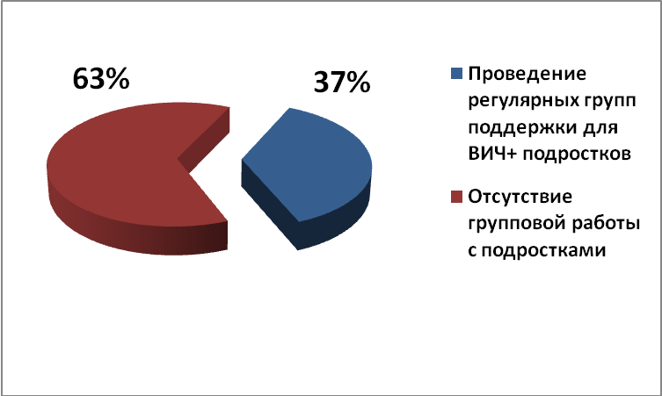
Fig 4. Regular support groups for HIV positive adolescents in the regions
□ Regular support groups for HIV positive adolescents in the regions
□ Lack of regular support groups for HIV positive adolescents in the regions
Unfortunately, regular support groups for adolescents, their importance notwithstanding, are conducted only in 7 regions (37%), including Poltava, Kiev, Donetsk, Odessa, Cherkassy, Khmelnitsky and Mykolayiv oblasts.
Neither adolescent leaders, not peer counselors are involved in this work in neither of the regions.
So, while the Global Fund programmes for HIV positive children are being reduced and other resources are limited, it is important to change the main approaches to the provision of services to adolescents in order to develop ARV treatment adherence and to prevent treatment fatigue.

ECUO PLH Initiatives to Develop Leadership Skills in HIV Positive Adolescents and to Change Approaches to Service Provision
Adolescent leaders supported by ECUO PLH initiated the establishment of the Youth Project – Teenergizer! (http://teenergizer.org/), which provided the platform for communication and mutual support of adolescents and young people, and for psychologists and peers to provide online counseling. In order to engage adolescents in the Teenergizer! Project, the adolescent leaders have independently created and supported accounts in the social media (VKontakte and Facebook). These online resources are very valuable for both adolescents and parent, as well as for specialists who provide services to HIV positive adolescents.
Besides, an online space has been created for safe communication of HIV positive adolescents in the closed group in VKontakte “Here you will find a story that is like yours”, for HIV positive adolescents which now has 52 participants (35 girls and 17 boys) from East Europe and Central Asia. This closed group is also maintained by adolescent leaders.
Importantly, the team that visited the regions included a senior manager of ECUO PLH and four adolescent leaders, who met and supported adolescents in the regions. After these meetings many teenagers continued their communication in the closed group in VKontakte, which provides them an opportunity to safely discuss HIV related topics and their HIV positive status with other adolescents living with HIV. Also, some adolescents openly discuss their concerns related to the interruption of ARV therapy, and the adolescent leaders, in their turn, underscore the importance of treatment adherence using their own experience. Thanks to it 8 adolescents renewed their ARV treatment that they had discontinued earlier due to various reasons.
At the same time ECUO PLH, which has its office in downtown Kiev, has been conducting once-monthly support groups for adolescents over 15 years of age since September 2014; these sessions are visited by 5-6 adolescents. Besides, the adolescents meet to discuss the Youth Project Teenergizer!, to develop its content and shoot videos, to run the account in VKontakte (they have 405 subscribers now) and in Facebook (197 subscribers).
Adolescent leaders provide technical assistance during their visits to the regions of Ukraine and EECA countries, participate in the training workshops for the specialists working with adolescents, and advocate the affordability of services for adolescents on the international regional and national levels.
Also, adolescent leaders support children living with HIV from other regions of Ukraine, who are hospitalized in OHMATDYT Clinic for Children Living with HIV/AIDS. This support has become possible since 2014 due to the cooperation established by ECUO PLH with oblast branches of All-Ukrainian Network of PLH and other regional organizations. Кроме этого, подростки-лидеры поддерживают ребят, живущих с ВИЧ, из регионов
Also, in 2014 – 2015 ECUO PLH with the support from UNICEF conducted 5 training workshops to change approached to the provision of services to children and adolescents. These training workshops were conducted in Chernivtsi, Ternopil, Uzhgorod and Poltava. Their participants included more than 60 specialists from 13 oblasts of Ukraine. Training participants included health and social workers from the Oblast AIDS Centres, who provide ARV therapy to HIV positive adolescents; social workers and psychologists from HIV servicing NGOs and adolescent leaders.
The results of these workshops are already felt in some oblasts. For instance, specialists from Khmelnitsky oblast have started their own support groups for adolescents. These groups are focused on discussion of acute and important issues. Adolescents can openly speak about HIV, sexual health, disclosure of their HIV positive status, etc.
An online platform children@ecuo.org is used for the professional support by the specialists working with HIV positive adolescents and to share the experience.

Conclusions and Recommendations
The analysis results indicate that health care facilities in Ukraine are primarily focused on the provision of medical services despite the fact that paediatricians often see the cases of ARV treatment interruption among adolescents or their refusal to take medicines (in 74% of the visited regions). Mainly, health workers do not have an opportunity to provide services to adolescents aimed at development of ARV treatment adherence and their retention in treatment programmes. Due to it the quality of life of children and adolescents living with HIV is deteriorating.
At the same time it was confirmed that adolescents rather often interrupt ARV therapy or take ARV drugs irregularly. In such cases it is especially important to have mechanisms to resolve crisis situations with the primary goal to restore the health status of adolescents and to develop their adherence to ARV therapy, to return and retain in the treatment programmes.
Assessment of this issue has demonstrated that health care facilities can either address the crisis situations independently, or involve social workers or psychologists from HIV servicing NGOs. Not all regions have such mechanisms in place. Only 7 regions had at least some mechanisms to resolve crisis situations related to ARV treatment interruption by HIV positive adolescents.
Efficiency of treatment of adolescents living with HIV is lower than in other population groups, which is explained by additional challenges related to the need to adhere to treatment. This means that after the disclosure of HIV positive status there is an acute need to continue regular work with adolescents in order to develop their treatment adherence.
Unfortunately only in 47% of the visited regions there were NGOs that had certain experience of work with HIV positive adolescents. Oftentimes, there is no further work with adolescents after the disclosure of their HIV positive status. Regular support groups for adolescents are being conducted only in 7 regions (37%), although this work is urgently needed. Neither adolescent leaders, nor peer counselors are involved in work in the regions.
So, in the conditions of reduced Global Fund support to the programmes for HIV positive children and taking into account limited resources, it is important to change approaches to the provision of services to adolescents, to preserve the existing experience of work with children and adolescents in the regions and to search for alternative funding sources.

The following recommendations have been developed on the basis of the conducted analysis:
- To preserve the existing experience of service provision to HIV positive children and adolescents there is need to establish a network of organizations working with adolescents with a technical support from ECUO PLH.
- Taking into account the difficult political situation in Ukraine, the armed conflict in the East of the country and economic crisis there is a need to change approaches to the provision of services to adolescents living with HIV.
- To ensure an open communication with adolescents there is a need to change social and professional norms among health and social workers.
- To develop ARV treatment adherence and to prevent treatment fatigue among HIV positive adolescents there is a need to involve adolescent leaders as peer counselors.
- There is a need to integrate services for HIV positive adolescents in the general system of service provision (Youth Friendly Clinics, AIDS Prevention Centres).
- NGO should provide services to HIV positive adolescents at the expense of funding from the local budgets (social assignment).
- Issues related to the needs of adolescents affected by HIV/AIDS should be raised at the meetings of city/oblast Coordination Councils.
- It would be good to conduct annual media campaigns to raise awareness of the general public and decision makers of the problems faced by HIV positive adolescents, to raise awareness of young people about safer behaviours and the need to be tested for HIV.

List of Abbreviations

ARV drugs | Medicines that suppress replication of HIV in the human body.
ARV therapy | Comprehensive therapy used to treat HIV infection. As a rule, it includes several ARV drugs.
HIV | Human immune deficiency virus
EECA | Eastern Europe and Central Asia
ECUO PLH | International Charitable Organization East Europe and Central Asia Union of People Living with HIV
PLH | People living with HIV
NGO | Non-governmental organization
AIDS | Acquired immune deficiency syndrome
UNICEF | United Nations Children’s Fund

http://allintoendadolescentaids.org/wp-content/uploads/2015/02/Ukraine.pdf
http://www.theglobalfund.org/ru/
Chernihiv, Ivano-Frankivsk, Chernivtsi, Poltava, Kiev, Donetsk, Odessa, Khmelnitsky, Volyn, Mykolayiv, Cherkassy, Rivne, Lviv, Ternopil, Zakarpattia, Vinnitsia, Kyrovograd and Zhytomyr oblasts and Kiev city.
http://www.network.org.ua/projects/current_projects/pokrashchennya-zhyttya-vil-pozytyvnykh-ditey-ta-yikh-simey-dity-plyus-/
Lviv, Khmelnitsky, Ivano-Frankivsk, Zakarpattia, Sumy, Poltava, Zhytomyr, Vinnitsia, Kherson, Kharkiv, Kiev, Zaporizhja and Chernivtsi oblasts.

